|  |
| --- |
|  |
| Room Booking System |
| User Guide |
|  |
| **Collister Keith** |
| **January 2016** |

|  |
| --- |
|  |

Contents

Overview 2

Introduction 2

System Requirements 3

Server (Minimum) 3

Client (Minimum) 3

Installation Instructions 3

Server 3

Client 4

Usage 5

Students 5

Teachers 6

Administrators 7

Server (Administrators) 8

Error Messages (Generic) 8

Error Messages (Specific Windows) 9

Edit Booking 9

Edit Room 10

Edit Period 11

Edit Teacher 12

Edit Student 13

Edit Department 14

Edit Class 14

Error Recovery Procedures/Backups and Restores 15

Client 15

Server 15

# Overview

## Introduction

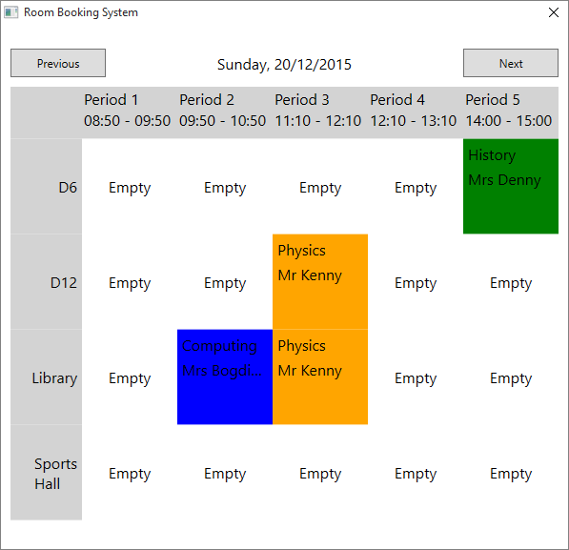The Room Booking System is designed to be an easy to use, scalable system for booking facilities, specifically school rooms. Its main overall features are customisability and inclusion of all users in the system, giving students restricted yet useful access to information usually only available to staff when using a traditional system.   
  
There are two main programs – the Server which is recommended to be run on a dedicated server machine, and the Client, which should run upon log-on on the standard computers used by students and staff around the school. The Clients connect to the Server and can then display and edit information on the system.  
  
The users are intended to be Teachers, Students, and Administrators. Each of these roles represents a degree of access to the system as well as the obvious “real-life” roles. An explanation of the system roles are given below.

|  |  |
| --- | --- |
| User Type | Role |
| Student | View bookings and receive notifications of scheduled bookings taking place in the room they’re currently logged on in. |
| Teacher | Can create and edit their own bookings, as well as having all the capabilities of Students. Can receive emails notifying them about changes to their bookings etc. |
| Administrator | Can create and edit any bookings, have all the capabilities of a student, and can create and edit more core system entries, such as the Rooms and Periods that Bookings can take place in/during. |

## System Requirements

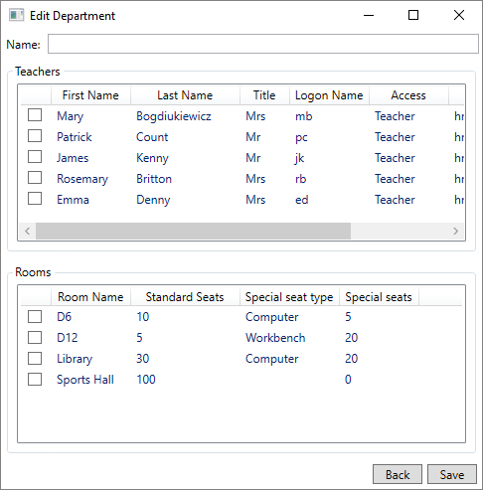Server (Minimum)

2GB free hard drive space.  
2GB RAM.   
2GHz processor.  
Windows XP or above.   
.NET Framework 4 or above.

Client (Minimum)

500MB free hard drive space.  
1GB RAM.   
2GHz processor.  
Windows XP or above.   
.NET Framework 4 or above.

## Installation Instructions

Server

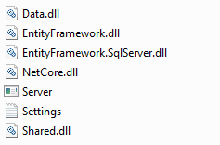The server’s files are as shown on the right: the Server.exe executable file which should be run to start the server; 5 DLL files which are necessary for the Server to run and should be stored in the same directory as it; the optional Settings.txt file which contains small tweaks to how the Server operates. Apart from the Settings file, all these files are required for the program to run and should be copied together to the installation directory. No further setup is required, the database will be created when needed by the system. Editing the Settings file may be desired if the system is set up slightly non-standardly.

The server should be set up by an administrator, and simply needs to be executed (run the Server.exe file) in order to start accepting client connections. By default it will create or use the database files in the same directory as it (called “Data.mdf”), and is otherwise standalone. Clients connect by default on port 34652, so the server machine should have this port open in firewalls etc.

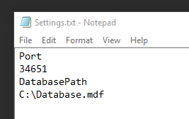Placing a file called “Settings.txt” in the same directory as the server enables a few customisations to be made.

Adding the lines  
DatabasePath  
<Path>  
will allow the server to use a different database path.

Adding the lines  
Port  
<Port>  
will allow the server to start using a different port for connections – note this must also be changed in the Client settings files (see Client installation instructions below) to allow them to connect. See the screenshot above for example data and format.

Client

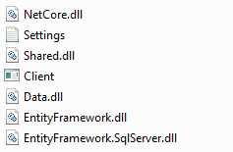The Client files are as shown to the right. The same 5 DLL files as the Server installation are included, but the “Settings.txt” file contains different content. All files should be in the same directory in order for the Client to work correctly. The Settings.txt file should be edited to reflect the desired connection settings etc, this is detailed below. Again, running the Client.exe file will start the client.   
  
Client installation is slightly trickier, and again should be done by an admin.   
While the client may be stored anywhere on a computer, it is useful (especially for students) for it to run on logon. This can be done many ways, the most usual being adding it to a list of startup programs given by a Windows Server installation. The easiest approach, and the one most independent of the existing system, is to add a shortcut to the Client.exe file to the “Startup” folder on the start menu – this can be accessed by right-clicking the “Startup” folder, and selecting “Open in new window”, then creating a shortcut to the Client executable there.

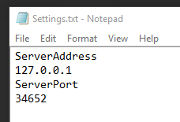Clients **require** a settings file, different to the Server for which the file is optional. This file must be named “Settings.txt” and be in the same directory as the Client executable. In this file the Server IP address and listening port **must** be specified, in the same format as the server’s file.

Adding the lines  
ServerAddress  
<IP Address>  
will change the IP address of the server to connect to.

Adding the lines  
ServerPort  
<Port>  
will change the port the Client attempts to connect through.

# Usage

## Students

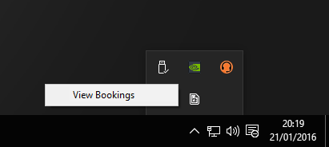To open the timetable, look for the icon  in the system tray. Left clicking this icon, or right clicking and selecting the “View Bookings” option in the displayed context menu, will display the main window.



Previous/Next buttons for changing days.

The current date being viewed.

A Booking made by Mr Kenny for Physics during period 3 taking place in both D12 and the Library.

The timetable window displays today’s bookings – your view might look different depending on the rooms/periods you have. You can use the “Next” and “Previous” buttons to navigate between days – the timetable will update to display the desired day. Hovering over a room will display more information about it, including the number of seats it has and the type of special seats (eg computers) that it has.

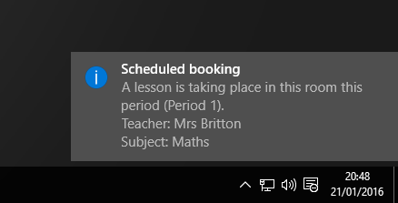You may see a popup when you’re using a computer in a room that’s been booked for the period you’re in – it will appear for a few seconds, displaying information about the booking, before vanishing. Again, this will look different depending on the booking and operating system.

This is to inform you that you may be interrupted while using the room by a class that have booked the room previously.

## Teachers

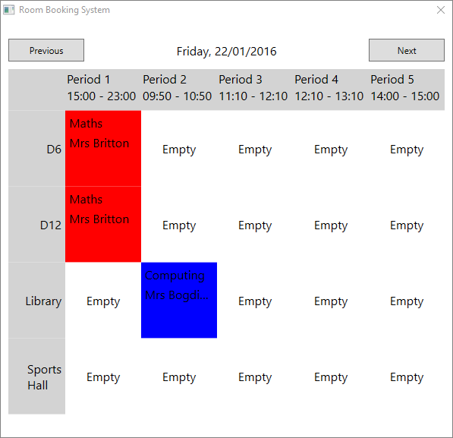

A Booking made by “Mrs Britton”.

An empty slot that can be booked.

Please first read the Student information section for an introduction to the most basic parts of the system. As a Teacher, you have all the rights of a student plus more – all the features accessible by you are from the Timetable window.

To add a new booking, click an empty cell. This will open the “New Booking” window and let you edit the details of this booking. Some data should be filled in initially, such as the room and period based on which empty cell you clicked.  
Note that you can’t book over an existing booking – if you try to submit a booking that conflicts with an existing one, you’ll receive an error message (see error message section at the end of this guide). Press the “Save” button at the bottom to save the booking to the system, and close the window to cancel making the booking.

The basic fields (explained in the text)

Rooms – tick all those desired.  
  
  
  
  
  
Students (optional) – select all that will be in the booking, and use the filters to reduce hassle.

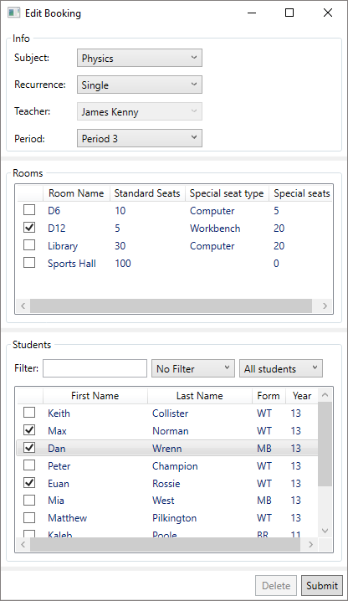

To edit an existing booking, click a cell containing one of your bookings. You cannot edit other teachers’ bookings. This will open up the same window as when creating a new booking, but the fields will be filled in as they were when you created it originally. You’re now free to adjust them until you’re happy, then press the “Save” button to submit or just close the window to cancel.

The Subject field is the Subject of the class you’re going to be teaching – the example here is Physics. Recurrence is how often this booking will recur – you can pick from “Single” (a one off booking), “Weekly” (will recur at the same time each week), “Fortnightly” (every two weeks), or “Monthly” (every 4 weeks). The “Period” field allows you to decide which period you want to make the booking for. Note that you can’t change the “Teacher” field – you can only make bookings for yourself.

The “Rooms” section lets you pick which rooms you want to book – some helpful information is displayed about them including how many and of what type the “Special Seats” are – these are workbenches/computer stations etc.

You can select Students from the Students area to attend the lesson (this is optional, it’ll only make it easier for them to see which lessons they’re involved in). You can filter the students by various criteria – type text into the filter box and select a filter, and the list will update to reflect students where the column indicated by the filter contains the text in the box. You can also filter by classes using the right-most drop-down box.

Field selector

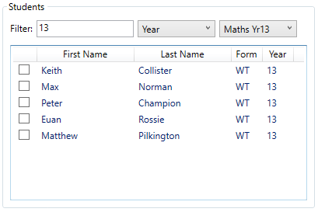

Filter text

Class selector

To delete a booking, simply open the window as if you were about to edit it, then press the “Delete” button. A confirmation dialog will show, giving you a chance to confirm your choice. Hitting “Yes” will permanently delete the booking, pressing “No” will cancel the deletion.

## Administrators

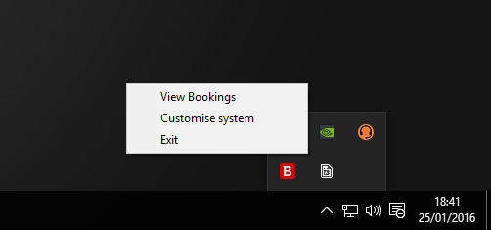Please first read both the Student and Teacher sections first, as they contain information about useful parts of the system as well as introducing windows etc.

As an administrator, you have access to all features of the system as a teacher and student, plus more. In practice, you’re able to view, create and edit bookings, including being able to create/edit bookings on behalf of any teacher. You can also edit background data, such as the Rooms, Periods, and lists of Teachers etc.

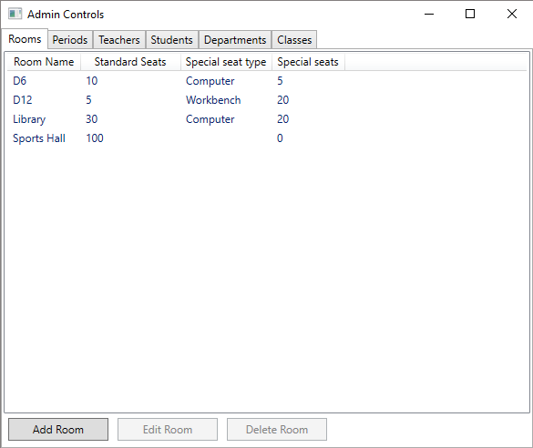

Entity tabs

Central Display

Editing buttons

This is all achieved through the Admin Control Panel, accessible from the taskbar icon’s context menu. There is another item on this menu for admins (compared to teachers), which is “Customise System”.

From the Admin Control Panel, you can modify all aspects of the system – from adding new bookable Rooms to editing Teacher’s email addresses. There are 6 tabs, each corresponding to a type of entity stored in the system – all these tabs have a similar interface, as shown on the right.  
A central view displays the items along with helpful information about them (in this case Rooms and associated data).  
Below the central display, there are 3 buttons – Add, Edit, and Delete, with obvious meanings. Pressing Delete will raise a confirmation dialog before actually deleting the entity (again, this is permanent), while pressing Add or Edit will display a window specific to each type of entity to allow you to customise the entry. Editing an existing entry will automatically fill in the fields on the window for you. Closing the window or pressing the “Back” button will cancel the changes – pressing the “Save” button will save the entry.

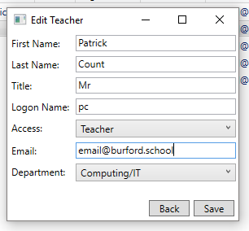Trying to submit invalid data into certain fields will cause an error message preventing you from saving the entry. These are covered in more detail in the “Error Messages” section of this guide.

Most fields have tooltips explaining their purpose.

## Server (Administrators)

Once the Server is started it will take a few seconds to load the internal model and settings (if present), and then displays a message stating that it’s started to listen for clients. Information on events will be printed as they occur – these include Clients connecting/disconnecting, and Bookings/Rooms/Teachers etc. being added/edited/deleted.  
Pressing any key while the server window has focus will shut down the server and disconnect all clients cleanly, also ensuring the database is detached correctly. This is the recommended method of shutting down the server.  
Opening the server after the first run will resume with the same state as when it was shut down – all Bookings, Rooms etc will persist between shut downs.

## Error Messages (Generic)

This section proves details of error messages that may occur regardless of what you’re currently doing with the program.

Failed to load Settings  
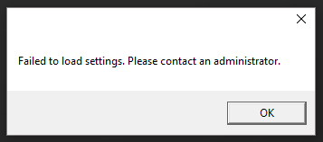This error message will occur if a client is started and doesn’t have a “Settings.txt” file in the same directory as it, or the file is in an invalid format. To fix this, the file must be created and filled in with correct information in a valid format. See the installation guide for instructions on creating this file, as well as the screenshot as an example of a valid file.

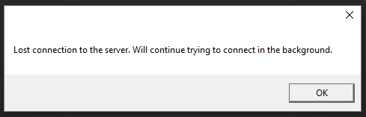Server Disconnection  
If the server goes down or the connection between the client and the server is lost for some reason during operation, this error message will appear. Simultaneously, all windows created by the Client process will close, and the taskbar icon will hide itself. This is to prevent users from interaction with the program while it attempts to reconnect.  
The Client will automatically attempt to reconnect to the server using the information provided in the settings file – this will continue until it either reconnects (at which point it will show the taskbar icon again), or until it is closed.

## Error Messages (Specific Windows)

This section provides information on all the error messages that users may encounter when using specific windows.

Edit Booking

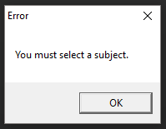Subject  
When on the Edit Booking window, attempting to submit the form before filling out all the fields will cause an error message to be displayed – leaving the “Subject” combobox unfilled will cause this specific error.  
This is an easy fix – select a Subject for the Booking to be allocated under, by choosing the relevant one from the drop down menu.

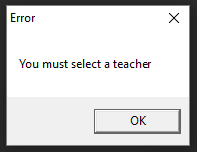Teacher  
Only administrators should ever encounter this error – when making a booking as a teacher, the “Teacher” field is automatically filled with their ID, as teachers can only make bookings on their behalf. The field is also uneditable by teachers. As such, a teacher should never see this as they lack the ability to change the field from its pre-set, working value.  
Administrators may see this if they attempt to submit a Booking without allocating a Teacher to it. To fix this, select a Teacher from the drop down list.

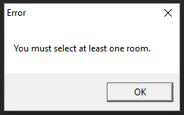Rooms  
Attempting to submit a Booking without selecting **any** rooms for the booking to take place in will cause this error message, as all Bookings must be allocated at least one room from the list. To fix this, check the checkbox to the left of the Room(s) that are desired in the list of bookable rooms so that at least one is checked.

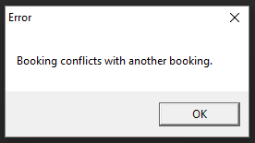Conflict  
Submitting a Booking where some of the Rooms selected are already being used by another Booking in the same period results in a conflict. Priority is given to the already existing Booking, so users aren’t able to overwrite existing bookings. The only true “fix” for this is a human one – reschedule your booking or request that the other teacher changes theirs.

Edit Room

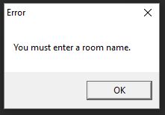  
Room Name  
Submitting a room with the same name as an existing one will trigger this error message – Room names must be unique within the system. To fix this, choose a different name for the Room, or delete/edit the Room with the same name.

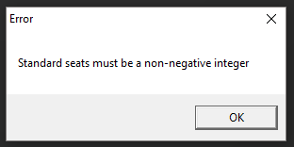Seats  
Leaving the “Seats” field blank, in an invalid format, or entering an invalid integer will cause this error message. A valid integer is one in the range 1 – 2.1×109 inclusive, so it is exceedingly unlikely that a user will enter a value that overflows the limit – it’s far more likely they’ll enter it in an invalid format. Valid formats are only sequences of digits; no punctuation or whitespace is allowed. To fix this, remove the offending characters or change value of the field.

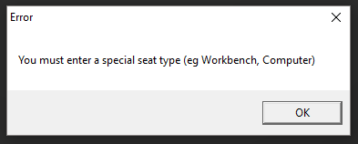Special Seat Type  
If the Special Seats field contains a valid value that’s greater than 0 (meaning that there are special seats in the room being edited), and the Special Seats Type field is empty, this error will be thrown. If a room has special seats, a description must be provided detailing what they are (eg Computers, Workbenches). This field will accept any text, so the only limit on entry to this is the length.

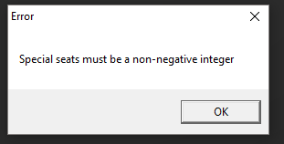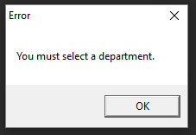Special Seats  
Leaving the Special Seats field blank, in an invalid format, or entering a number lower outside of the inclusive range 0 – 2.1×109 will cause this error – the number of special seats provided must be either 0 or positive. Valid formats only include a sequence of digits, excluding punctuation and characters. To fix this, either enter the number of valid seats in a valid format, or enter a 0 to indicate there are none.

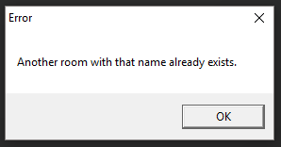Department  
The Department combobox must have a value in order for the form to submit – the initial blank field is invalid. The department is the body of teachers in charge of this room. Selecting a department (eg Maths) from the drop down list will fix this error.

Duplicate  
Entering a name for a room when the same name’s been allocated to another room will cause an error – room names must be unique (although this is the only restriction on them). To fix this, either edit/delete the conflicting room, or use a different name for the currently editing room.

Edit Period

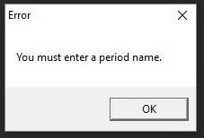  
Period Name  
All periods must have names for easy identification by users of the system (eg “Period 1”). Leaving the “Name” field blank on this window will cause this error message to be displayed, and can be fixed by entering any name into the field.

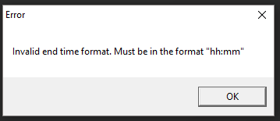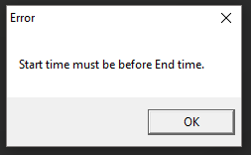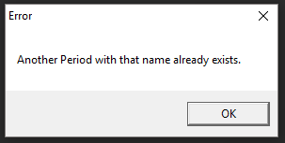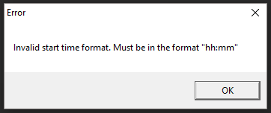Start Time  
The “Start Time” field is the hours and minutes that the period begins – valid formats are “hh:mm”, where the hours are between 0-23, minutes between 0-59, both separated by a colon. For example, a period might start at “08:50” (which can also be entered as “8:50”), but “24:30” and “12:10:30” are both invalid.  
Entering an invalid format or leaving this field blank will display the error message, and can be fixed by either entering a valid time or correcting the format.   
  
End Time  
The “End Time” field behaves exactly the same as the “Start Time” field, only it denotes the end time of the period. Fixes for this error message are identical to those of the Start time.   
  
  
Start before End  
The Start time of a period must be before the End time – a period from “8:50” to “9:50” is valid, but from “10:50” to “9:50” is invalid. Usually this error is as a result of a typo or entering the wrong time into the wrong field, so to fix this just double check the field values.   
  
  
Duplicate  
Two periods can’t share the same name – this is again the only restriction on the name. To fix this error, either rename this entry, or edit the conflicting entity.

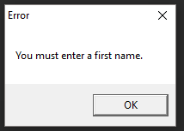Edit Teacher

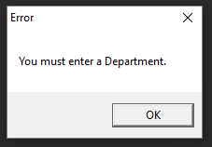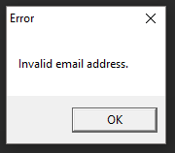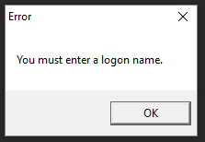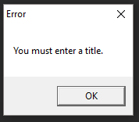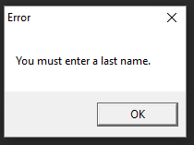  
First Name  
A teacher must have a first name. It needn’t be unique, but it must be present. This error will show when no name has been entered, so to fix the error simply enter a first name.   
  
Last Name  
Identical to the First Name error – teachers must have last names with exactly the same restrictions as the first name.  
  
Title  
A teacher must be given a title – this can be any text, but the most common titles will be “Mr”, “Mrs”, “Ms” etc.   
  
Logon Name  
A teacher (indeed, any user) requires a logon name – this must be the username they use to log onto a school computer, and is used to determine which user has logged on when a Client starts up. This is required but has no other limits – it can be numbers eg “09135”, or text eg “MEB”, as long as it matches the actual user’s username.  
  
Email  
Teacher’s email addresses can be input in order to provide automatic notifications about booking changes when they’re made. This field isn’t required, but if there is text in the field it must be in a valid email format (the most standard form is “address@provider.com”, although there are variations). To fix this error, either remove the invalid email address or correct the format.  
  
Department  
This error is shown if the Teacher isn’t assigned to a Department – this field can be filled with any of the existing departments in the system, selectable from the drop-down menu on the combobox, but must be filled.

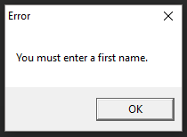Edit Student

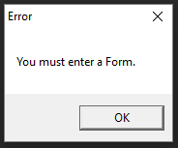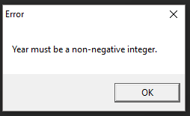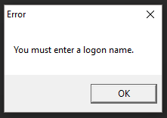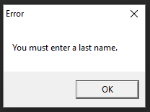  
First Name  
A student must have a first name to be identified by teachers by. It needn’t be unique, but it must be present. This error will show when no name has been entered, so to fix the error simply enter a first name.   
  
Last Name  
Identical to the First Name error – students must have last names with exactly the same restrictions as the first name.  
  
Logon Name  
A student requires a logon name – this must be the username they use to log onto a school computer, and is used to determine which user has logged on when a Client starts up. This is required but has no other limits – it can be numbers eg “09135”, or text eg “MEB”, as long as it matches the actual user’s username.  
  
Year  
The student’s year is required (eg “13”, “7”). Attempting to submit a Student without filling this field in, or leaving it in an invalid format, will cause the error message – the year can be any non-negative integer.  
  
Form  
This error message shows if the student’s “Form” field is left blank – like the Year field, this is mostly used by teachers while searching for Students to include in their lessons. The form can be any string, but must be present.

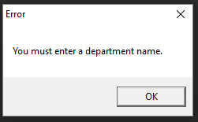Edit Department

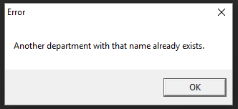  
Name  
All departments must have a name for easy identification by users. The name can be anything, but must be present. If this error shows, add text to the “Name” field.  
  
Duplicate  
The Department’s name must be unique – entering a name that clashes with another department will cause this error to show, and to fix it you must either change the name of this new department, or edit/delete the existing clashing one.

Edit Class

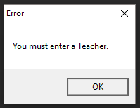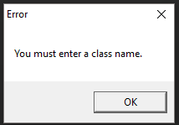  
Name  
All classes must have names, again for user identification – this name can be any text, but must be present. To fix this error, enter a name for the class into the “Name” field.  
  
Teacher  
A class must have a Teacher that owns it – this can be selected from the drop-down box on the field, so it’s impossible to enter “invalid” input. Not selecting a teacher is the only error that can be made, which can be fixed by simply selecting one of the teachers available.  
  
Duplicate  
A class’s name must be unique, as otherwise users won’t be able to differentiate between two identically named classes. Entering a name that’s already in use by a different class will cause this error to be shown, and can be fixed by changing the name of this class to an unused name, or editing/deleting the other class entity sharing the same name.

## Error Recovery Procedures/Backups and Restores

All of the information used by the system (besides the core files) is stored in a very few files. These can simply be copied to another location (either onsite or preferably offsite for greater protection), and replaced to restore a backup.

Data files are fairly small – the Settings files for programs are very small (<1024 bytes), while the actual database is usually <50MB) – so backups can be taken regularly with very little cost. It’s recommended to take a backup at the end of each day, keeping copies for up to a week. This approach will use less than half a gigabyte without compression, which is an easily managed size. Additionally, an offsite weekly backup is recommended for extra security of data – again, as the file sizes are so small it would be relatively easy to set up a very cheap/free online weekly backup of the data.

Client

To backup this module, copy the “**Settings.txt**” file to a safer location (preferably offsite or offline).  
To restore the data, copy the “Settings.txt” from the safer location into the same directory as the Client executable.  
  
Clients store no information pertaining to the system themselves – the only file that may be changed when using a Client is the “Settings.txt” file in the same directory as it, and this is likely the same file as is used by all other clients. As such this data isn’t particularly important – it can easily be fixed by simply rewriting the file as was done during installation.

Server

To backup this module, copy the “**Settings.txt**” files from the Server executable’s directory, along with the “**Data.mdf**” file from the Server’s directory or the database directory pointed to by the “Settings.txt” file, into a safer location.  
To restore the data, copy the “Settings.txt” files from the safer location into the same directory as the Server executable, and the “Data.mdf” file into the Server directory or the directory pointed to by the “Settings.txt” file if it’s specified.  
  
The Server stores almost all the information pertaining to the system inside the “Data.mdf” file – this is a large file, and may take a while to copy. However, it is entirely self-contained, so may be replaced with a different version without any extra hassle.  
The “Settings.txt” file contains some minor settings used by the Server, which should be backed up for completeness. However, just as with the Client, it can be recreated quickly just as done when installing, so isn’t as important to backup as the main database file.